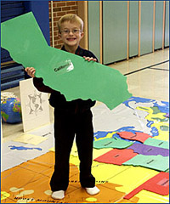

State Puzzle Poster

You will be creating a poster that reflects your understanding of your state identifiers. Your teacher will be giving you the tools to complete this project. You will need to know the following 8 pieces of information for your puzzle poster:

- The state flag
- The state flower
- The state motto
- The state tree
- The state name
- The state bird
- The state animal
- The date

For each item above, you will use the internet to find the information for your state. You will include 2-5 sentences about each state identifier. Your sentences should include:

- Name of the identifier
- Two details about the identifier.

For each identifier you will perform the following steps:

Step one: Pick the identifier that you are going to research.
Step two: Do a search to find the information you are looking for.
Step three: Take notes on the information that you found.
Step four: Write out your sentences on your identifier.
Step five: Check to make sure that you have “perfect” sentences.
Step five: Type out your information into word, using the format that your teacher explains.

Example:
California’s state flower is the Golden Poppy, also known as Eschscholtzia. It was adopted by the state on March 2, 1908. If you are interested in planting this flower in your yard, be advised that the flower will bloom from February to March.

